Computer Networks Lab Report
Submitted By
V. JEEVAN
RA2411030050037
Under the guidance of
Dr. Mallika
(Assistant Professor, School of Computing)
in partial fulfilment for the award of the degree
of
BACHELOR OF TECHNOLOGY
in
DEPARTMENT OF COMPUTER SCIENCE AND ENGINEERING WITH CYBER SECURITY
Of
FACULTY OF ENGINEERING AND TECHNOLOGY

SRM INSTITUTE OF SCIENCE AND TECHNOLOGY,
TIRUCHIRAPPALLI
Academic Year: 2026–2027
Date: 23 October 2026

Computer Networks Lab – Experiment 2 (Lab 3)
Experiment Title
Router Configuration (Configuring Passwords, Console, VTY, and Interface Configuration).
Aim
To configure a Cisco router using the Command Line Interface (CLI), secure administrative and remote access by setting console, enable, and VTY passwords, configure IP addresses on Gigabit Ethernet interfaces to connect two distinct subnets, and verify inter-subnet routing.
Software and Hardware Requirements
• Cisco Packet Tracer (network simulation software)
• Cisco 2911 Integrated Services Router (Router0)
• Generic PCs (PC0 and PC1)
• Copper Straight-Through cables (RJ-45)
• Windows PC to run the simulator (project saved as lab 3.pkt)
Brief Theory
Router: A networking device operating at Layer 3 (Network Layer) of the OSI model that forwards data packets between different computer networks using logical IP addresses and routing tables.
Cisco IOS Command Modes: User EXEC Mode (Router>) is used for basic diagnostics; Privileged EXEC Mode (Router#), accessed via enable, allows system maintenance; Global Configuration Mode (Router(config)#), accessed via configure terminal, modifies system-wide parameters; Interface Configuration Mode configures IP addresses and interface activation; Line Configuration Mode secures terminal access lines.
Router Security: The console password secures direct physical terminal connections, the enable password restricts administrative escalation, and VTY passwords secure inbound Telnet/SSH sessions.
Inter-Subnet Routing: Hosts on different subnets (192.168.1.0/24 and 192.168.2.0/24) cannot communicate directly at Layer 2. A router acts as the default gateway for each subnet and routes packets between its interfaces.
Step-by-Step Procedure
1. Open Cisco Packet Tracer and build the network topology in the Logical workspace.
2. Place a Cisco 2911 router (Router0) and two PCs (PC0 and PC1) representing two distinct subnets (Fig. 7).
3. Connect PC0 FastEthernet0 to Router0 GigabitEthernet0/0 and PC1 FastEthernet0 to Router0 GigabitEthernet0/1 using Copper Straight-Through cables.
4. Open Router0 CLI and enter no to skip the initial configuration dialog.
5. Secure console, privileged EXEC, and remote VTY access using the following commands:
Router> enable
Router# configure terminal
Router(config)# line console 0
Router(config-line)# password cisco
Router(config-line)# login
Router(config-line)# exit
Router(config)# enable password cisco
Router(config)# line vty 0 4
Router(config-line)# password cisco
Router(config-line)# login
Router(config-line)# exit
6. Configure the router interfaces and save the configuration:
Router(config)# interface gigabitEthernet 0/0
Router(config-if)# ip address 192.168.1.1 255.255.255.0
Router(config-if)# no shutdown
Router(config-if)# exit
Router(config)# interface gigabitEthernet 0/1
Router(config-if)# ip address 192.168.2.1 255.255.255.0
Router(config-if)# no shutdown
Router(config-if)# exit
Router(config)# end
Router# copy running-config startup-config
7. Configure PC0 with IPv4 address 192.168.1.2, subnet mask 255.255.255.0 and default gateway 192.168.1.1 (Fig. 8).
8. Configure PC1 with IPv4 address 192.168.2.2, subnet mask 255.255.255.0 and default gateway 192.168.2.1.
9. In Router0 CLI, run show ip interface brief to verify the interface addresses and status (Fig. 9).
10. From PC0 Command Prompt, run ping 192.168.1.1 and then ping 192.168.2.2 to test gateway reachability and cross-subnet connectivity (Fig. 10).
IP Address Configuration
Device | Interface | IPv4 Address | Subnet Mask | Default Gateway / LAN
Router0 | GigabitEthernet0/0 | 192.168.1.1 | 255.255.255.0 | LAN 1 (192.168.1.0/24)
Router0 | GigabitEthernet0/1 | 192.168.2.1 | 255.255.255.0 | LAN 2 (192.168.2.0/24)
PC0 | FastEthernet0 | 192.168.1.2 | 255.255.255.0 | 192.168.1.1
PC1 | FastEthernet0 | 192.168.2.2 | 255.255.255.0 | 192.168.2.1
Both PCs use static addressing. Each default gateway points to the corresponding router interface so traffic destined for another subnet is forwarded to Router0.
Testing and Verification
Router Interface Status: show ip interface brief showed GigabitEthernet0/0 (192.168.1.1) and GigabitEthernet0/1 (192.168.2.1) as up/up. Unused interfaces GigabitEthernet0/2 and Vlan1 remained administratively down.
Default Gateway Ping: ping 192.168.1.1 from PC0 yielded four replies with bytes=32, time<1ms, TTL=255, and 0% packet loss.
Inter-Subnet Ping: ping 192.168.2.2 from PC0 showed the first packet timing out, followed by three replies with TTL=127. The result was 4 packets sent, 3 received and 1 lost (25% loss). The supplied report explains the initial timeout as ARP discovery while the router resolves PC1's MAC address.
Result
A router network topology utilizing a Cisco 2911 router and two host PCs was constructed in Cisco Packet Tracer. Console, enable, and VTY passwords were set. Router interfaces GigabitEthernet0/0 and GigabitEthernet0/1 were configured and enabled. Inter-subnet communication between PC0 (192.168.1.2) and PC1 (192.168.2.2) via Router0 was tested through ICMP ping.
Conclusion
This experiment demonstrated router configuration using Cisco IOS CLI commands. Securing console, VTY and privileged EXEC access improves network management security. Enabling router interfaces supports Layer-3 routing between distinct subnets, and configuring default gateways enables communication across routed networks.
Screenshots / Practical Evidence
The following screenshots are taken from the supplied report and document the router topology, PC configuration, connectivity tests and router CLI.
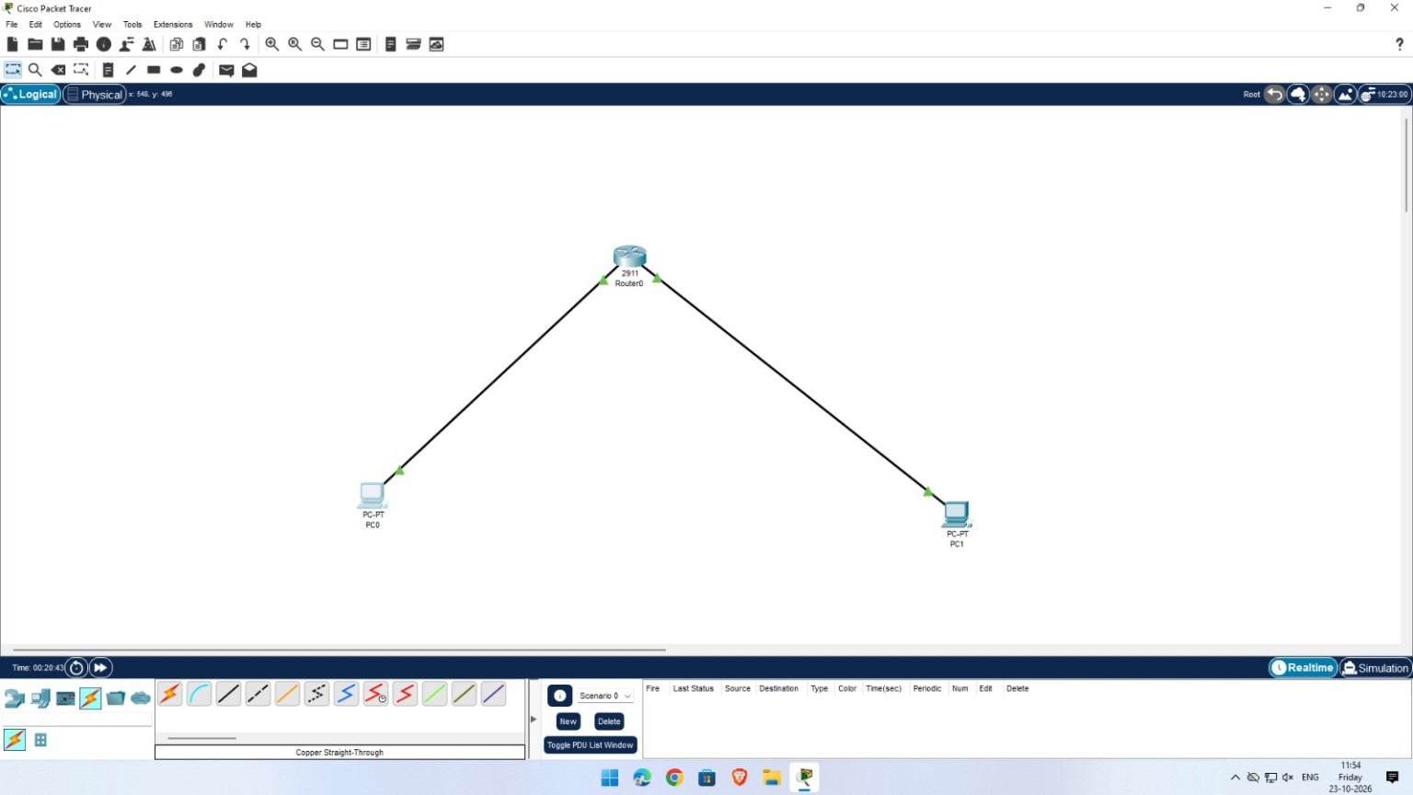
Figure 1. Packet Tracer network topology showing Router0 connected to PC0 and PC1.
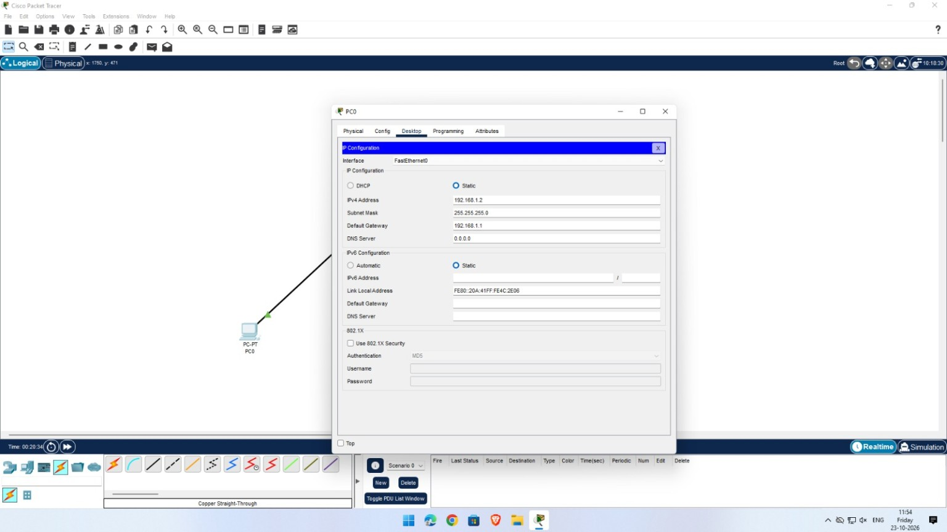
Figure 2. PC0 static IPv4 configuration (192.168.1.2) and default gateway (192.168.1.1).
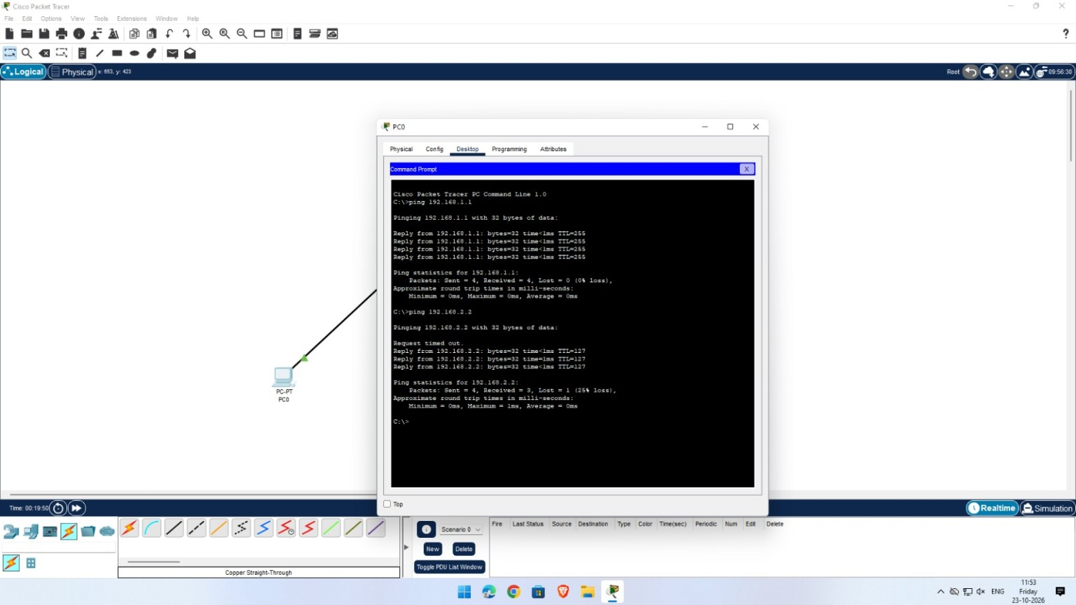
Figure 3. Command Prompt showing ping tests to the default gateway and PC1.
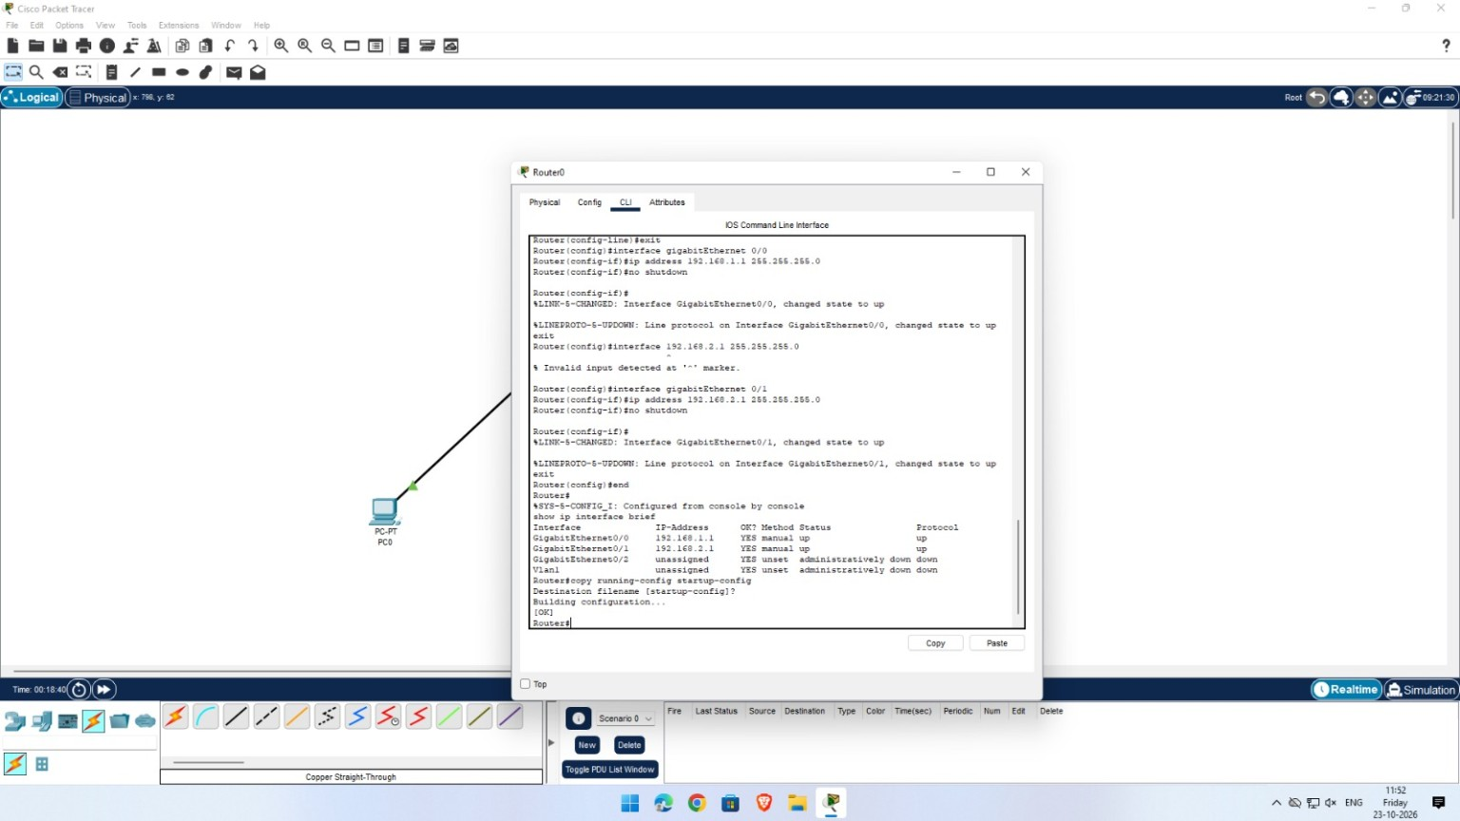
Figure 4. Router CLI showing interface configuration, interface status, and saving the configuration.

